J Gynecol Obstet Hum Reprod 52 (2023) 102535


Contents lists available at ScienceDirect
Journal of Gynecology Obstetrics and Human Reproduction
ELSEVIER journal homepage: www.elsevier.com

Guidelines

Management of female pelvic organ prolapse—Summary of the 2021 cr。SSMark
HAS guidelines
Anne-Ce,cile Pizzoferratoa,*, Caroline Thuillierb, Aure,lien Ve,narac, Nicole Bornszteind,
Sylvain Bouquete, Me,lanie Cayracf, Martine Cornillet-Bernardg, Odile Cotelleh, Florence Couri, Sophie Cretinonj, Pia De Reilhack, Je,rome Loriaul, Franc,oise Pelletm,
Marie-Aime,e Perrouin-Verben, Anne-Gae“lle Pourceloto, Christine Revel-Delhomp, Benoit Steenstrupq, Thomas Vogelr, Loïc Le Normandn, Xavier Fritela
a Department of Obstetrics and Gynaecology, La Miletrie University Hospital, Poitiers, France, INSERM CIC 1402, Poitiers University, Poitiers, France b Department of Urology, Grenoble Alpes University Hospital, Grenoble, France
c Department of Digestive Surgery, Angers University Hospital, Angers, France
d General practice ofﬁce, Evry France, College of General Medicine, Paris, France
e General practice ofﬁce, Lamastre, France, College of General Medicine, Paris, France f GYNEPOLE, Obstetrics and Gynecology Center, Montpellier, France
g Mousseau clinic, Evry-Courcouronnes, France
h Department of Obstetrics and Gynaecology, AP-HP, GHU Sud, Antoine Be,cle、re Hospital, Clamart, France
i Department of Urology, Foch Hospital, University of Versailles-Saint-Quentin-en-Yvelines, Suresnes, France j Department of Obstetrics and Gynaecology, AP-HP Louis Mourier Hospital, Colombes, France
k Medical Gynecology Ofﬁce, Nantes, France
l Department of Digestive Surgery, St-Joseph Hospital, Paris, France
m French Association of Gougerot Sjo“gren and Dry Syndromes, Paris, France n Department of Urology, Nantes University Hospital, Nantes, France
o Department of Gynecology and Obstetrics, AP-HP, GHU-Sud, Bicetre Hospital, Le Kremlin Bicetre, France p Clinical practice guidelines Unit, French National Authority for Health, Saint Denis La Plaine, France
q Department of Urology, Rouen University Hospital, Rouen, France
r Geriatric Department, University Hospital of Strasbourg, Strasbourg, France
A R T I C L E I N F O |  | A B S T R A C T
Article History:  Received 11 January 2023  Accepted 12 January 2023  Available online 16 January 2023 |  | When a patient presents with symptoms suggestive of pelvic organ prolapse (POP), clinical evaluation should include an assessment of symptoms, their impact on daily life and rule out other pelvic pathologies. The prolapse should be described compartment by compartment, indicating the extent of the externalization for each. The diagnosis of POP is clinical. Additional exams may be requested to explore the symptoms associated or not explained by the observed prolapse. Pelvic ﬂoor muscle training and pessaries are non-surgical conservative treatment options recommended as ﬁrst-line therapy for pelvic organ prolapse. They can be offered in combina- tion and be associated with the management of modiﬁable risk factors for prolapse. If the conservative therapeu- tic options do not meet the patient’s expectations, surgery should be proposed if the symptoms are disabling, related to pelvic organ prolapse, detected on clinical examination and signiﬁcant (stage 2 or more of the POP-Q classiﬁcation). Surgical routes for POP repair can be abdominal with mesh placement, or vaginal with autologous tissue. Laparoscopic sacrocolpopexy is recommended for cases of apical and anterior prolapse. Autologous vaginal surgery (including colpocleisis) is a recommended option for elderly and fragile patients. For cases of isolated rec- tocele, the posterior vaginal route with autologous tissue should be preferentially performed over the transanal route. The decision to place a mesh must be made in consultation with a multidisciplinary team. After the sur- gery, the patient should be reassessed by the surgeon, even in the absence of symptoms or complications, and in the long term by a primary care or specialist doctor.  © 2023 Elsevier Masson SAS. All rights reserved.
Keywords:
Pelvic organ prolapse Guidelines
Pessary
Pelvic ﬂoor muscle training Surgery
Outcomes

* Corresponding author.
E-mail address: anne-cecile.pizzoferrato@chu-poitiers.fr (A.-C. Pizzoferrato).
https://doi.org/10.1016/j.jogoh.2023.102535
2468-7847/© 2023 Elsevier Masson SAS. All rights reserved.

Introduction
Female pelvic organ prolapse (POP) is a common pathology whose prevalence and severity increases with age. Prevalence is difﬁcult to estimate with precision as the evaluation methods (symptom

A.-C. Pizzoferrato, C. Thuillier, A. Venara et al. Journal of Gynecology Obstetrics and Human Reproduction 52 (2023) 102535

questionnaires, clinical examination) vary from one study to another, but it is estimated to affect around 30 to 50% of women [1]. POP is associated with many pelvic symptoms (urinary, genital-sexual, ano- rectal) that can signiﬁcantly alter a woman’s quality of life [2,3]. Its management is based on pelvic ﬂoor muscle (PFM) training, pessary placement, or reconstructive surgery. The therapeutic choice consid- ers the patient’s expectations, their symptoms, the impact on their quality of life, the type and grade of prolapse, the risk of recurrence, and the risk of postoperative complications.
On request from the French Ministry of Solidarity and Health with a view to regulating the medical devices used for prolapse surgical
repair in France, the HAS (Haute Autorite de la Sante, French National
Authority for Health) have published clinical guidelines for managing patients with POP entitled “Female pelvic organ prolapse, therapeutic management”. These guidelines were drawn up by a working group and then reviewed by external reviewers in accordance with HAS methodology.
The objective of the current paper is to present a summary of the HAS guidelines. This summary is intended to inform professionals managing women with POP about the various therapeutic strategies. Speciﬁc focus has been put on the relevance of non-surgical manage- ment (PFM training and gynecological pessaries) and deﬁning indica- tions for surgery as well as procedures for informing and monitoring patients.

Symptoms associated with pelvic organ prolapse
The most speciﬁc symptom for the presence of POP is the wom- an’s perception of a vaginal bulge which can increase on stress and which is detectable intermittently during the day or during vari- ous activities. Pelvic heaviness and urinary symptoms (urinary incontinence, voiding dysfunction or urinary urgency) are fre- quently associated with POP. While anorectal disorders such as anal incontinence, obstructed defecation, or fecal urgency seem more frequent in cases of posterior prolapse, they can also be pres- ent in any type of POP. Symptoms associated with POP are more bothersome and more frequent when the prolapse descends to the hymen or beyond [1,4,5]. Depressive symptoms and sexual func- tion disorders are also frequently associated with POP and should be investigated as part of the work up [2,6]. On the other hand, symptoms as chronic pelvic pain or repeated bleeding are not associated with POP and women presenting such symptoms should be investigated for other pathologies.
Validated symptom and quality of life self-questionnaires are use- ful tools because they make it possible to assess symptoms in a stan- dardized and reproducible way and to assess the impact of the available treatments. Scales focusing on self-image are also a compo- nent ofthe evaluation of the impact of POP.
When a woman presents with symptoms suggestive of POP, it is recommended to (expert agreement (EA)):
- identify the pelvic symptoms: perceived vaginal bulge, pelvic heaviness, functional urinary or anorectal disorders;
- assess the extent of the discomfort felt by the patient and ask her to specify the dominant symptom (the most bothersome);
- assess the impact on quality of life;
- assess the impact of the symptoms on daily life (impact on physi- cal or sexual activity, functional, psychological, or social disabil- ity);
- ask the woman what she expects from her treatment.

Initial clinical assessment
When a patient presents with symptoms suggestive of POP, clini- cal evaluation should include:

- an assessment of symptoms, ideally using symptom and quality of life self-questionnaires
- a pelvic examination to conﬁrm the diagnosis and rule out other pelvic pathologies.

Symptom assessment can be based on the PFDI-20 (Pelvic Floor Distress Inventory) or APFQ (Australian Pelvic Floor Questionnaire) questionnaires, both of which have been validated in French [7,8].
The pelvic examination is conducted at rest (static) then during pushing, coughing, and restraint (dynamic) with a full and then empty bladder [9]. In order to characterize the different prolapsed compartments, the clinical examination can be carried out using valves (or a hemispeculum), in a supine or gynecological position, and then standing if the prolapse is not visualized. Certain elements such as vaginal atrophy in postmenopausal women, vaginal perme- ability, functional quality of PFM assessed by vaginal examination, or urinary leakage on coughing will help to adapt the treatment.
Two classiﬁcations can be used to determine the prolapse stage: the International Continence Society (ICS) classiﬁcation (POP-Q) [10], and the Baden-Walker classiﬁcation [11] (Annex 1). However, the use of POP-Q is encouraged as it can also be used to monitor treat- ment.

Management of pelvic organ prolapse should include a pelvic clinical examination to rule out any concomitant pelvic pathology.
The prolapse should be described compartment by compart- ment, indicating the extent of the externalization for each as well as the genital hiatus (EA). This description of pelvic organ prolapse can be graded using a classiﬁcation.
If the patient presents or feels symptoms that are not consis- tent with the initial clinical examination, it is recommended to repeat the examination with straining in a standing position and at the end of the day (EA). A pessary test may also be offered.
Risk factors related to lifestyle, which may be modiﬁable, could contribute to the occurrence or progression of POP: obesity, tobacco use, certain physical and sports activities, lifting and carrying heavy loads, a sedentary lifestyle, defecation or urinary pushing, chronic cough, etc. [12,13]. Other non-modiﬁable factors such as physiologi- cal age, gynecological and obstetrical history, hormonal status, a dis- ease affecting collagen (e.g., Ehlers-Danlos syndrome), neurological disorders causing denervation of the pelvic ﬂoor (spina biﬁda, cauda equina syndrome, etc.) should also be considered when deciding on the therapeutic choice.

Potential or aggravating risk factors should be assessed during the initial clinical assessment and then during follow-up, par- ticularly in the case of prolapse recurrence (EA). Any identiﬁed modiﬁable factors should be managed when possible (EA).

Complementary ﬁrst-line examinations
Dynamic pelvic MRI is a non-irradiating, non-invasive and pain- less examination, allowing morphological and functional analysis of the pelvis and the pelvic ﬂoor. It does not replace clinical examination and is not indicated for the diagnosis of POP. However, it may be indi- cated by the specialist in certain complex situations where the clini- cal examination is not totally contributory; in particular in the case of posterior compartment prolapse, suspicion of enterocele, recurrence

A.-C. Pizzoferrato, C. Thuillier, A. Venara et al. Journal of Gynecology Obstetrics and Human Reproduction 52 (2023) 102535

after a ﬁrst prolapse treatment, or in women who have had a hyster- ectomy [14,15].
Urinary tract ultrasound can be useful, especially in cases ofexter- nalized prolapse which can have repercussions on the upper urinary tract.
Urodynamic assessment provides information on bladder and urethral sphincter function with dynamic measurement of detrusor pressure during the continuous ﬁlling of the bladder, urethral sphinc- ter pressure, and bladder emptying. In the case of POP, it can unmask occult stress urinary incontinence (SUI), bladder emptying disorder, detrusor hyperactivity or hypocontractility likely to alter functional outcomes of surgery. However, its interest is still under debate and none of the urodynamic parameters seem to be decisive in the man- agement of prolapse [14].
Uroﬂowmetry is the non-invasive assessment of the free ﬂow of urine voided per unit time and the post-void residual volume. It can be useful in case of exteriorized prolapse and/or symptoms of voiding dysfunction.

Pelvic organ prolapse diagnosis is a clinical diagnosis requiring no additional examinations (EA).
Additional exams may be requested to explore the symp- toms associated with the prolapse or not explained by the observed pelvic organ prolapse (urgency, defecatory urgency, anal or urinary incontinence, voiding dysfunctions, dyschezia, pain, bleeding, etc.).

How to inform the patient?
Despite the major impact on a woman’s quality of life, fewer than half of the women with signiﬁcant POP symptoms seek care. Analysis of the literature shows that insufﬁcient knowledge and mispercep- tion about POP and its symptoms are the main obstacles to seeking care [16-18]. Patient information should be improved to ensure opti- mal adherence and compliance to treatment. This information, ide- ally supported by leaﬂets, allows them to participate in the choice of treatment within the framework of a shared medical decision.

Patients with pelvic organ prolapse should be informed that (EA): - the natural progression of a prolapse is usually slow;
- treatment is only necessary if the prolapse causes discom- fort, or in the case of complicated prolapse;
- bleeding and pain are abnormal signs that require investi- gation to ﬁnd their cause;
- the frequency of pelvic organ prolapse follow-up consulta- tions with a specialist depends on the progression and the woman’s request;
- PFM training can improve the discomfort and symptoms associated with prolapse;
- a pessary can improve the discomfort and symptoms asso- ciated with prolapse and does not affect the quality of sex- ual life;
- surgery, when indicated, is very rarely an emergency.

Non-surgical management of POP
Only symptomatic or complicated pelvic organ prolapse should be treated.

Pelvic ﬁoor muscle training
The main objective of PFM training is to reduce or slow down the progression of symptoms and to reduce the impact of the pathology on quality of life. It includes the following components: education (awareness, modiﬁcation of urination habits), muscle strengthening (contraction against resistance, co-activation of transverse abdominal muscles, biofeedback, electrostimulation), and work on posture. Very few studies have evaluated the impact of lifestyle and dietary meas- ures on the symptoms associated with prolapse, but it seems that education sessions about pelvic ﬂoor disorders, and the physiology and anatomy of genital tract, can improve patients’ symptoms and quality of life [19,20].
The aim of PFM exercises is to optimize PFM functions in terms of coordination, strength and endurance to provide better structural support to pelvic organs. Studies have shown that these exercises improve the symptoms associated with POP and can improve the POP stage for moderate stages [21-23].
Although abdominal hypopressive training is widely used in France, no study has been able to show its superiority over PFM train- ing [24]. Lumbo-pelvic stabilization techniques can improve the symptoms associated with POP but without superiority compared with PFM exercises [25].

Pelvic ﬂoor muscle training is one of the non-surgical conserva- tive treatment options recommended as ﬁrst-line therapy for moderate pelvic organ prolapse (grade C). It can be offered in combination with the ﬁtting of a pessary.
The number of sessions is deﬁned by the physiotherapist and does not have to be speciﬁed on the medical prescription. Physiotherapy assessment should be communicated to the pre- scriber in the interest of multidisciplinary management (EA).
Poor patient adherence and compliance to PFM training can be an obstacle to its effectiveness. The patient should be informed that her active participation will contribute to the quality of the results (EA).

Gynecological pessary
A pessary is a device inserted into the vagina to maintain the pro- lapse and relieve associated symptoms. Patients’ knowledge of pes- sary use is poor and certain patient characteristics seem to hinder pessary use (young age, active sexuality, etc.) [26,27]. However, these devices are effective since they provide almost immediate symptom relief in 50 to 80% of cases. The symptoms most often improved are urinary symptoms (voiding dysfunction, urgency) and vaginal symp- toms (heaviness, vaginal bulge); improvement in digestive symptoms is not consistently found in studies [28-30]. The effectiveness of pes- saries on symptoms seems equivalent to surgical treatment and they can be associated with PFM training.
Early failure of pessary use (e.g., expulsion) appears to be associ- ated with a short vaginal length (≤6 cm) and a wider genital hiatus (4 ﬁnger width) [28]. Other authors have found that a history of pro- lapse surgery, hysterectomy, or posterior stage POP is associated with pessary failure [29,31]. A high body mass index or a high POP stage are inconstantly found to be factors in the failure of pessary use [32,33].
There are currently about twenty types of pessaries the most com- mon of which are made of latex or silicone. Silicone is preferrable to latex because it is more ﬂexible and less porous, thus preventing bac- terial proliferation and trauma to the mucosa. The most common form of pessary is the ring pessary, regardless of the type or stage of POP. If the ﬁrst type of pessary is unsuccessful, other pessaries can be

A.-C. Pizzoferrato, C. Thuillier, A. Venara et al. Journal of Gynecology Obstetrics and Human Reproduction 52 (2023) 102535

tried, such as the Gellhorn or the Donut pessary. The cube pessary can be offered to women capable of handling it themselves regularly. Dish pessaries with button may be indicated for urinary incontinence associated with POP.
Use "on demand" is possible in women who are embarrassed by their POP symptoms only in certain risky activities or circumstances. In postmenopausal women, local estrogen therapy (cream, capsule, or tablet) improves the tolerability of the pessary and may be offered to limit the trophic risks (erosion, poor positioning) [34].
Procedures for ﬁtting, removing and for follow-up by a profes- sional are explained in Annex 2.
The ﬁrst follow-up consultation after the insertion of the pessary can be scheduled 2 to 6 weeks later; the follow-up can then be adapted according to the type of pessary, vaginal discharge, and the patient’s ability to remove it for cleaning.

Fitting of a ﬁrst-line pessary should be offered to all patients presenting with symptomatic pelvic organ prolapse, whatever their age and the stage of the prolapse (grade C). Before inser- tion of the pessary, the patient should be informed about how to use the pessary and its follow-up, the risk of pessary expul- sion, and the vaginal discharge associated with its use (a patient information sheet is available in annex 3).
Occasional use of the pessary is possible in women who are embarrassed only in certain risky activities or circumstances (for example episodes of winter cough or allergy). Education in self-management of the pessary would appear to be an impor- tant element for continued use.

A pessary test may be performed if the link between the symp- toms reported by the patient and the prolapse is unclear, or if the patient experiences signiﬁcant discomfort despite a non-exterior prolapse.

Role of other conservative measures (laser/radiofrequency, hormone therapy ...)
Local estrogen therapy is effective on vulvovaginal atrophy, uri- nary incontinence, or overactive bladder that may be associated with POP in postmenopausal women (genitourinary syndrome of meno- pause, GSM) [35] and can be recommended (EA). Vaginal moistur- izers/lubricants can be offered as an alternative but only seem to be effective on vaginal atrophy in GSM. There are no data to support the use of laser or radiofrequency in the management of POP (EA).

Surgical management of POP

Clinical and paraclinical assessment before POP surgery
The aim of the clinical assessment carried out by the specialist before POP surgery is to (see chapters 1 and 2):
- identify all the symptoms associated with the prolapse (urinary, digestive, gynecological, and sexual), and assess the importance of these symptoms, their impact on daily living, the disability, and the patient’s expectations of treatment,
- assess whether the clinical examination (size and type of POP) explains the symptoms and the complaint;
- ensure that the patient has undergone recommended pelvic screening.
- Clinical assessment should also evaluate the patient’s medical proﬁle (associated pelvic pathology, risk factors, co-morbidities), and the treatments already carried out including their modalities and their effectiveness.

- The objectives of the additional examinations, left to the discre- tion of the specialist practitioner, may be to:
- better specify the anatomical defect (dynamic MRI, colpo-cystode- fecography (CCD), etc.)
- specify the link between the symptomatology (urinary or anorec- tal) and the prolapse or prevent a postoperative functional com- plication (uroﬂowmetry, urodynamic assessment, anorectal manometry, etc.)
- detect any associated pelvic pathology (pelvic ultrasound, renal bladder ultrasound, etc.).

The superiority of dynamic MRI compared to a pelvic clinical examination to assess anatomical defects has not been demonstrated for anterior or middle compartment prolapse. It can provide addi- tional information and/or change the proposed approach in the case of posterior or multicompartmental prolapse (detection of entero- cele, rectal prolapse, etc.) [36-37]. CCD seems to be more sensitive than dynamic MRI but more irradiating [37]. Given the lack of known beneﬁt, the type of dynamic imaging examination (dynamic MRI, CCD) is left to the choice of specialist practitioners, in particular depending on the availability of the examinations.
Although the prevalence of bladder emptying disorders increases with the degree of bladder prolapse, the usefulness of performing systematic uroﬂowmetry in order to identify patients at greater risk of persistent postoperative voiding disorders has not been estab- lished, even when performed with restrained prolapse [14].
The interest of urodynamic assessment in terms of predicting postoperative outcome (risk of postoperative hyperactivity, postop- erative urinary incontinence, urinary retention, etc.), and modiﬁca- tion of care has not been proven either [14,38]. In the UK, the National Institute of Clinical Excellence (NICE) recommendations published in 2019 specify that it is not necessary to perform urody- namic tests to assess SUI or mixed urinary incontinence before POP surgery [39]. However, the NICE guidelines also state that urody- namic testing may be beneﬁcial if the diagnosis is unclear or if the woman has voiding dysfunctions, anterior or apical prolapse, or a his- tory of surgery for SUI.
If the patient presents with defecatory obstruction syndrome or anal incontinence associated with prolapse, anorectal manometry can be useful to diagnose dyssynergic constipation (anismus), dys- functions of rectal sensitivity, and contraction of the anal sphincter. These disorders must be diagnosed before surgery because their treatment is non-surgical and they increase the risk of failure of sur- gery [40]. In the event of permanent exteriorized prolapse, there is a risk of repercussions on the upper urinary tract and renal impairment. In this situation, a renal ultrasound can be performed to look for pyelocaliceal dilation [41].

For women presenting with pelvic organ prolapse without other symptoms, no additional examination has been shown to be useful before prolapse surgery (Grade C). Any additional examinations should be adapted to the associated pelvic symp- toms (Grade C).
When a surgical procedure is envisaged, dynamic imaging may be indicated in women with posterior prolapse to better clarify the degree of anatomical support. In the absence of any spontaneous or masked urinary signs, urodynamic assessment is not recommended (grade C). If necessary, complete urody- namic assessment (with voiding phase) will help to understand the mechanisms of these urinary symptoms and inform the patient.
When the woman presents with a defecatory obstruction syndrome or anal incontinence (dyschesia or incontinence), it is recommended to seek the advice of a specialist (EA). The

A.-C. Pizzoferrato, C. Thuillier, A. Ve/nara et al. Journal of Gynecology Obstetrics and Human Reproduction 52 (2023) 102535

specialist may possibly decide to carry out additional examina- tions (such as anorectal manometry) to detect any anorectal dysfunction which could impact the functional outcome of the surgery.
If concomitant hysterectomy is planned with the surgical POP repair, any pelvic imaging examinations should be adapted to the proven or suspected uterine pathology.

Eligibilty criteria for surgery
After assessing POP-associated symptoms and their impact on quality of life, performing a pelvic examination to conﬁrm the diag- nosis, and carrying out additional examinations, if necessary, the decision to perform repair surgery should be made in accordance with the expectations and wishes of the woman. At this stage, the woman should be reminded about the progressive mode of the pro- lapse and the absence of therapeutic urgency. In the case of recurrent prolapse, risk factors of recurrence (factors of abdominal hyperpres- sure) should be investigated as the reoperation is in itself a risk factor for failure.

Before proposing prolapse surgery, the patient should be informed of all the therapeutic options (no treatment, PFM training, pessary, surgery) so as to be involved in a shared deci- sion-making process (EA).
If the conservative therapeutic options do not meet the patient’s expectations, surgery should be proposed if the symp- toms are disabling, related to pelvic organ prolapse, detected on clinical examination and signiﬁcant (stage 2 or more of the POP-Qclassiﬁcation) (EA).
Modiﬁable risk factors for prolapse should be investigated and managed prior to surgical treatment (EA).
The surgical indications for recurrent prolapse are the same as for the non-recurrent form.

Surgical indications
Surgical routes for POP repair can be abdominal (laparoscopy or laparotomy) with mesh placement, or vaginal with or without a mesh (vaginal route with autologous tissue). The use of vaginal meshes is currently suspended in France other than in the setting of a clinical study.

Autologous vaginal surgery
Autologous vaginal surgery consists of POP repair via the vagina using the patient’s tissues (without a mesh). Reported recurrence rates following such surgery vary from 0 and 92%, but are difﬁcult to assess due to the large number of surgical techniques (sacrospinous ligament ﬁxation, McCall culdoplasty, uterosacral suspension, the Manchester procedure, colporrhaphy, etc.) [42-44].
Functional and subjective outcomes following autologous vaginal surgery appear to be similar to sacrocolpopexy outcomes without a signiﬁcant difference in terms of the risk of reoperation. However, sacrocolpopexy gives better anatomical results for anterior and apical prolapse repair, with a lower risk of recurrence [45,46]. The main advantage of these vaginal techniques is that the operating time is shorter and they can be carried out under spinal anesthesia, two arguments which make them particularly suitable for elderly and fragile patients.

Abdominal route: sacrocolpopexy
The sacrocolpopexy technique consists of interposing a non- absorbable polypropylene or polyester prosthesis between the blad- der and the vagina, with ﬁxation on the uterine isthmus and then on the anterior presacral ligaments in the region of the promontory. Its success rate is high, between 74 and 98%, and the laparoscopic route offers the best compromise between outcome and morbidity [47-49].
There is no scientiﬁc data to recommend the preventive use of a posterior prosthesis in the absence of symptomatic posterior colpo- cele [41].

Colpocleisis
Colpocleisis consists of anterior and posterior colpectomy com- bined with anterior-posterior colporrhaphy with a view to removing the vaginal cavity. The effectiveness of this technique is estimated at between 91% and 100% according to the various studies, with low operative morbidity in patients over 80 years old [50,51]. Colpocleisis is an option for patients with POP who no longer wish to have sexual intercourse through the vagina, or who are at surgical and/or anesthetic risk.

Treatment of symptomatic posterior colpocele
There are several treatment techniques for symptomatic posterior colpocele: posterior sacropexy, autologous vaginal surgery, transanal surgery. Laparoscopic posterior sacropexy consists of dissecting the rectovaginal septum on the anterior face of the rectum and attaching the mesh to the rectum and/or to the levator ani muscles. This approach is indicated for the treatment of "high" rectocele associated with an enterocele, and is the preferred route for cases of internal rectal prolapse (rectal intussusception) which cannot treated by the vaginal route. The technique has a low recurrence rate (2.2 to 3.6%) and gives good anatomical results but does not always improve defe- cation disorders [52,53].
For cases of isolated, low and middle rectocele, at 6 months the posterior vaginal route with autologous tissue is superior to the trans-anal route in improving symptoms of constipation (25% versus 50%), incomplete evacuation (25% versus 56%), and digital maneuvers (25% vs 50%), but the anatomical results are comparable [53]. It also seems that the reoperation rate for recurrence is lower after an autol- ogous vaginal approach [54].

Concomitant hysterectomy
Concomitant hysterectomy by abdominal surgery (sacrocolpo- pexy), increases perioperative morbidity and postoperative recovery time without improving functional and anatomical results [55]. If the indication is retained, subtotal hysterectomy can limit the risk of mesh exposure [41].
For women with cervix elongation, POP repair outcomes may be improved by concomitant total hysterectomy or amputation of the cervix.
For the vaginal route, hysteropexy by sacrospinous ligament ﬁxa- tion is as effective as hysterectomy with suspension of the apex [41]. In the particular case of permanently externalized uterine prolapse (grade 4), the risk of recurrence is higher if the uterus is preserved [56].

Concomitant surgery for stress urinary incontinence
Symptomatic SUI tends to be associated with low-grade prolapse (present in 55% of women with grade 2 vs. 33% for grade 4), whereas grades 3 and 4 prolapse are more often associated with voiding dys- functions [57].
For patients with overt SUI (occurring with cough or the Valsalva test, in the absence of any prolapse reduction maneuver), a midure- thral sling (MUS) placement at the time of POP repair reduces the risk of persistent SUI (0 vs 40%) (van der Ploeg, 2018). However,

A.-C. Pizzoferrato, C. Thuillier, A. Ve/nara et al. Journal of Gynecology Obstetrics and Human Reproduction 52 (2023) 102535

prolapse surgery without MUS can treat up to 30% of preoperative cases of SUI [57].
For patients with occult SUI (leakage of urine occurring during a prolapse reduction maneuver during the clinical examination in a patient not describing symptoms of incontinence), MUS placement at the time of POP repair reduces the risk of postoperative SUI (1 vs. 15%) [58]. However, POP surgery without MUS can treat up to 60% of cases of occult SUI [57]. There is currently no clinical or urodynamic test to individually predict the risk of postoperative SUI.
In addition, concomitant SUI surgery exposes the patient to spe- ciﬁc morbidity. Van der Ploeg’s meta-analysis [58] reports a rate of 14% of serious adverse events following single-stage combined sur- gery (bladder perforations, ureteral wounds, mesh exposure, pain related to MUS, persistent voiding dysfunctions.. .) versus 8% in the absence of concomitant surgery.
We therefore recommend not treating SUI at the same time as the prolapse surgery, provided that the patients are warned of the possi- bility ofa two-stage surgery.

Patient information
The surgeon must inform the patient about the various possible surgical options and involve the patient in choosing the modality best suited to her particular situation (EA).
When surgery is envisaged, information about postoperative fol- low-up, the risk of recurrence, the signs that should lead to consulta- tion and that may predict a complication (in particular mesh erosion), and the action to be taken in the event of complications must be provided to the patients.
OVERALL:

The choice of the surgical technique is a shared medical deci- sion that depends on the symptoms, the type of pelvic organ prolapse, the patient’s underlying status (state of health, comorbidities), and the patient’s expectations.
If the patient’s predominant choice is for anatomical results and long-term efﬁcacy, laparoscopic sacrocolpopexy is recom- mended because it results in a better anatomical outcome, with low morbidity for cases of apical (hysteroptosis, tracheloptosis, or prolapse of the vaginal fundus) and anterior prolapse (cysto- cele) (grade C).
On the other hand, if the patient’s priority is to minimize intra- and perioperative risks compared to long-term efﬁcacy, autologous vaginal surgery (including colpocleisis for the very elderly population) is a recommended option (grade C).
When sacrocolpopexy is indicated, it should be performed by laparoscopy (grade B).
There is no argument to systematically place a posterior inter-rectovaginal mesh to prevent the risk of rectocele at the time of a sacro(hystero)colpopexy (grade C).
For cases of isolated, low and middle rectocele, the posterior vaginal route with autologous tissue is superior to the transanal route and is recommended.
It is also recommended not to systematically treat overt or occult SUI at the same time as surgical POP repair. In this case, the patient should be informed of the possibility of a two-stage surgery and warned of the risk of persistence of postoperative incontinence (EA).

Hysterectomy is not recommended for the treatment of prolapse apart from exteriorized uterine prolapse treated vaginally. In the treatment of exteriorized pelvic organ prolapse via the vaginal route, a hysterectomy can help limit the risk of recurrence.

For women with cervix elongation, POP repair outcomes may be improved by concomitant total hysterectomy or amputation of the cervix.
If the hysterectomy must be performed through the abdominal route with prosthetic reinforcement, the cervix should be conserved (subtotal).
Patient information must be standardized with clearly deﬁned items. The patient must be informed in particular of the expected beneﬁts and the speciﬁc, frequent, or serious complications of each therapeutic option, as well as of the modalities of postoperative fol- low-up (EA). The patient should also be informed of the risk of pro- lapse recurrence with or without associated symptoms (EA).
Since the decree of September 22, 2021 governing the practice of acts associated with the placement of suspension implants intended for the treatment of POP by the abdominal route (sacropexy), the decision to place a mesh must be made in consultation with a multi- disciplinary team after having considered all the solutions for the management of the prolapse. This multidisciplinary team must include at least a urologist and a gynecologist, and if necessary, a gas- troenterologist or a visceral surgeon, and a doctor or a physiothera- pist specialized in pelvic ﬂoor disorder rehabilitation.
(https://www.legifrance.gouv.fr/jorf/id/JORFTEXT000044087701).

Follow-up after prolapse surgery

Postoperative consultation
During the postoperative consultation, the health professional should assess patient satisfaction, and to look for speciﬁc mesh com- plications (generally only slightly or not symptomatic) or signs of recurrence. However, the patient should consult as soon as she expe- riences symptoms suggestive of a complication.
Mesh erosion occurs in 0-12% of cases with an average follow-up of 17-26 months, recurrence in 0-25% of cases at 13-23 months, and persistence of symptoms in 2-31% of cases at 13-23 months [59 -61].
Signs suggestive ofa mesh complication can be:
- gynecological: persistent vaginal bleeding, vaginal discharge, vag- inal and pelvic pain, vaginal odor, dyspareunia, partner pain dur- ing intercourse;
- urinary: recurrent urinary tract infections, voiding disorder;
- digestive: rectal bleeding, anal pain, defecatory obstructive syn- drome, etc.

The patient should be reassessed by the surgeon during a postop- erative consultation, even in the absence of symptoms or complica- tions, and in the long term by a primary care or specialist doctor (EA).
The woman should be seen in a postoperative consultation as soon as any abnormal symptoms appear (e.g., fever, bleeding, intense pain, malaise, vomiting, urinary retention, etc.) (EA).
The patient should be told to consult her doctor or her surgeon if she experiences a sign suggestive of a complication (AE).

Measures to improve surgical prognosis
Gradual resumption of physical, professional or leisure activities is possible from the third postoperative week in the absence of discom- fort or pain (to be adapted to professional conditions in terms of fre- quency, duration and intensity).
There is no scientiﬁc argument against having sexual intercourse with penetration beyond a period of 4 weeks after POP repair.
Post- or perioperative PFM training has been evaluated in several meta-analyses, but none have provided arguments for or against since there are no good quality or reproducible studies on the subject

A.-C. Pizzoferrato, C. Thuillier, A. Ve/nara et al. Journal of Gynecology Obstetrics and Human Reproduction 52 (2023) 102535

[62-63]. Its indication is left to the discretion of the surgeon (depending on the educational needs of the patient).

Declarations of Competing Interest
None.

Acknowledgement
We would like to thank the French National Authority for Health
(Haute Autorite de la Sante (HAS)) for allowing us to reproduce the
patient leaﬂet about the use of pessaries. It can also be consulted on the website www.has-sante.fr under the heading: All our publica- tions.

Annex 1. POP-Q and Baden-Walker classiﬁcations - Progre、s en
urologie (2016) 26, S105-S109

Baden-Walker Classiﬁcation
The degree of the prolapse eversion is quantiﬁed during stress using the hymen as a ﬁxed anatomical point

Stage | Localization of the prolapse
1 | Intravaginal (halfway to the hymen)
2 | At the vulva (to the hymen)
3 | Beyond the vulvar oriﬁce (halfway past the hymen)
4 | Eversion (maximum descent)

POP-Qclassiﬁcation (Pelvic Organ Prolapse Quantiﬁcation System) -

International Continence Society (ICS)

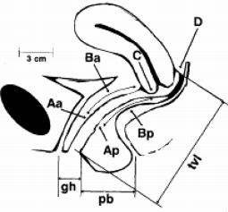
Bump et al. 1996
The descent of the pelvic organs is assessed by measuring (in cen- timeters from the hymen) six deﬁned points distributed over the anterior vagina (Aa and Ba), the dome (C and D) and the posterior vagina (Ap and Bp), and three anatomical markers (gh, pb, and tvl):

● Aa: point located in the middle part of the anterior vaginal wall 3 cm from the urethral meatus, it corresponds to the position of the bladder neck. Its position can vary between -3 and +3 cm in relation to the hymen
● Ba: lowest point or slope of the anterior vaginal wall. By deﬁni- tion, in the absence of prolapse it has the same value as Aa (-3 cm), and has a value between -3 and +tvl in cases of complete eversion
● C: corresponds to the cervix or the vaginal cuff in patients who have undergone hysterectomy. Its value is between -tvl and +tvl
● D: corresponds to the position of the posterior vaginal cul-de-sac or the rectouterine cul-de-sac in non-operated patients. Hypertro- phic elongation of the cervix is conﬁrmed when point C is signiﬁ- cantly distant from point D, thus reﬂecting an extended cervical mass. If there is no cervix, this measurement is not taken. Its value is between -tvl and +tvl
● Ap: point located in the middle part of the posterior vaginal wall 3 cm from the hymen. It can vary between -3 and +3 cm in rela- tion to the hymen
● Bp: most distal point of the posterior vaginal wall located, by deﬁ- nition, at -3 cm in the absence of prolapse and which has a posi- tive value in cases of complete eversion of the vaginal cuff in hysterectomized patients
● gh: diameter of the genital hiatus, distance between the urinary meatus and the vulvar fork.
● tvl: total vaginal length from the bottom of the vagina (or poste- rior cul-de-sac) to the hymen.
● pb: thickness of the perineum, distance between the vulvar fork and the center of the anus.

The six points are measured in a patient who has previously emp- tied her bladder, during straining. The hymen plane has, by deﬁni- tion, a value of zero: measurements above are negative and measurements below are positive. The tvl is only measured at rest; ideally, the gh and pb are measured both at rest and during straining.

Classiﬁcation
From these nine measurements, the prolapse is classiﬁed into one of ﬁve stages:
- Stage 0: no prolapse observed, all points are more than 3 cm above the hymen
- Stage 1: the lowest point of the prolapse remains 1 cm above the hymen
- Stage 2: the lowest point is between + 1 cm and - 1 cm on either side of the hymen
- Stage 3: the lowest point extends more than 1 cm below the hymen, but remains at least 2 cm less than the total vaginal length
- Stage 4: any point beyond stage 3; eversion.

Annex 2. Pessary choice and follow-up - according to HAS
recommendations “Female pelvic oragn prolapse: therapeutic management”
How to choose a pessary?
Pessaries can be offered to most patients with genital prolapse.

A.-C. Pizzoferrato, C. Thuillier, A. Venara et al. Journal of Gynecology Obstetrics and Human Reproduction 52 (2023) 102535
The most frequently used pessaries are the Ring and Cube pessaries. The Cube pessary is more suitable for young women for use on demand.
The Ring pessary is easier to use and is suitable in most cases.
The Donut pessary is used more in 2nd intention because it can be difﬁcult to insert into the vagina. The Dish pessary is sometimes used for urinary leakage associated with prolapse.

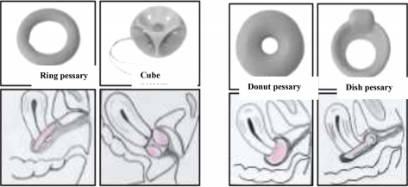

Main proposed pessaries
PREFER SILICONE PESSARIES OVER LATEX PESSARIES

As a rule, a pessary can be used for several years (2-3 years). It must be changed at the ﬁrst sign of a change in appearance (cracking, breakage).
What size to choose?
For a ring pessary:
In most cases, the 70 mm size is suitable for premenopausal women or women with good vaginal trophicity.
The 76 mm size can be used if the vaginal cavity is large and with good trophicity.
The 64/62 mm size is more suitable for postmenopausal women with vaginal atrophy.
It is useful to inform the patient that she may need to try several pessaries to ﬁnd the most suitable one.
For a Cube pessary:
A 36 mm Cube pessary (or a standard size Gyn & Cube) will most often be suitable
A pessary should NOT HURT, or cause EMBARRASSMENT DURING MICTION or DEFECATION. Always try the smallest size that does not get in the way or slip down.

Two simple rules to explain to patients: - too small, it moves or falls out
- too big, it gets in the way
How to place and remove the pessary?

Pessary placement | Pessary removal
1 Empty bladder  2 In lithotomy position  3 Lubricate the pessary  4 Bend the pessary between the thumb and index ﬁnger of the dominant hand  5 Spread the labia minora with the non-dominant hand  6 Introduce the pessary into the vagina  7 THE PESSARY MUST LOCK BEHIND THE PUBIC SYMPHYSIS  The cervix is positioned in the center of the ring in most casesA Ring pes- sary should be bent at the notches The button of a Dish pessary should be positioned under the urethra | For the Ring pessary:  1 Locate the notches in the pessary with your index ﬁnger  2 Hook the pessary with the index ﬁnger  3 Rotate the pessary to bring one of the notches back into the axis of the vagina  4 Pull gently and continuously until completely removed  For the Cubepessary:  1 Follow the cord with the index ﬁnger  2 Pass the index ﬁnger between the pessary and the vaginal wall to remove the suction effect  3 Hook the pessary with your index ﬁnger  4 Pull gently until completely removed.
 | (continued)

A.-C. Pizzoferrato, C. Thuillier, A. Venara et al. Journal of Gynecology Obstetrics and Human Reproduction 52 (2023) 102535
(Continued)

Pessary placement | Pessary removal
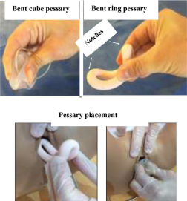
DO NOT PULL ON THE CORD
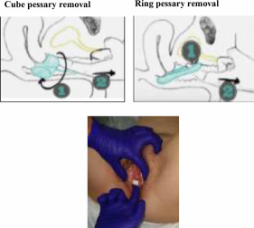



Once the pessary is in place Cleaning the pessary

1 It shouldn’t hurt | Wash the pessary in soapy water
2 Pass a ﬁngertip between the pessary and the vaginal wall to check the absence of tis- | Cubepessary: Ideally cleaning every day
sue tension  3 Test tolerability and stability: standing and squatting, coughing and walking  The bladder can be emptied during the insertion of the pessary. It is then necessary to reassure the patient and to insist on the interest of the pessary which will allow a better emptying of the bladder. | Ring pessary: Minimum cleaning every 4-6 months, ideally every 15 days to 1 month (if cleaned by the patient)

A.-C. Pizzoferrato, C. Thuillier, A. Ve/nara et al. Journal of Gynecology Obstetrics and Human Reproduction 52 (2023) 102535
It may be useful to have a test pessary box at the patient’s disposi- tion in which case a protective glove should be used for positioning.
The patient can then buy the appropriate pessary directly.
ALL PESSARIES CAN BE SELF-MANAGED BY THE PATIENT
What are the side effects ?

Disadvantages | Complications
Vaginal discharge with a pessary is normal. The pessary can:  - slip down to the vaginal oriﬁce during daily activities or sports  - fall out, especially during defecation.  CORRECTION OF CONSTIPATION IS ESSENTIAL |  | Bleeding from vaginal erosions (abrasions) Infections, smelly discharge Pain  Vaginal incarceration (if the pessary is neglected).
The application of local estrogen or hyaluronic acid-based cream improves long-term tolerability pessary and may be used, especially in menopausal women

Annex 3. HAS information sheet for patients on the use of gynecological pessaries

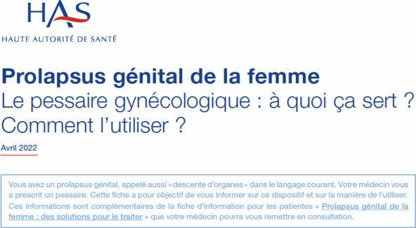

A.-C. Pizzoferrato, C. Thuillier, A. Ve/nara et al. Journal of Gynecology Obstetrics and Human Reproduction 52 (2023) 102535

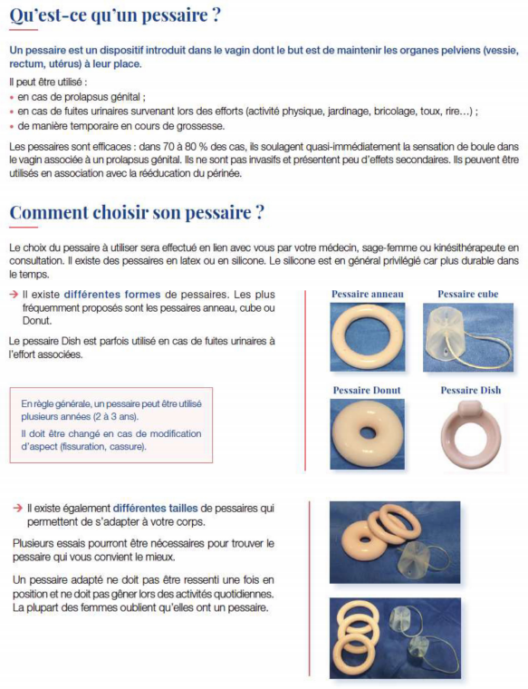

A.-C. Pizzoferrato, C. Thuillier, A. Ve/nara et al. Journal of Gynecology Obstetrics and Human Reproduction 52 (2023) 102535

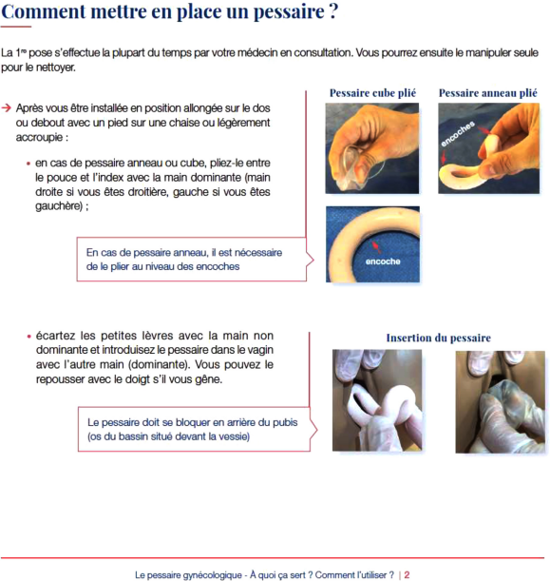

A.-C. Pizzoferrato, C. Thuillier, A. Ve/nara et al. Journal of Gynecology Obstetrics and Human Reproduction 52 (2023) 102535

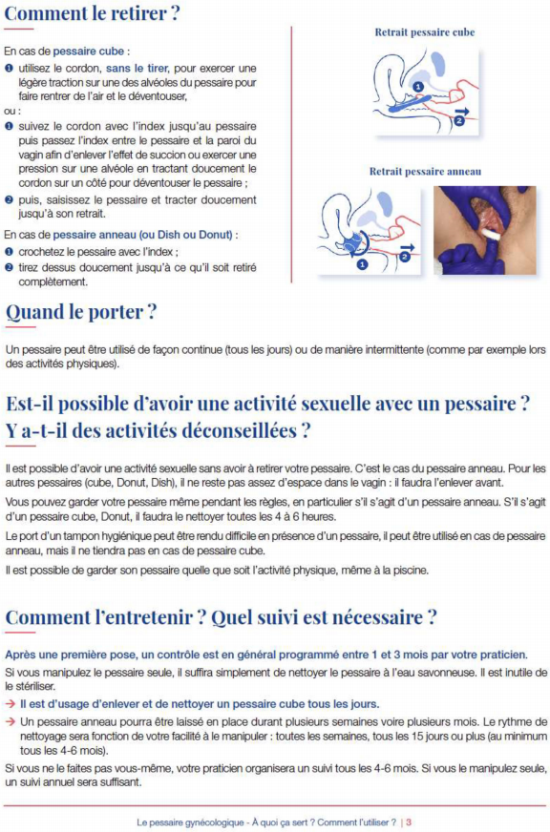

A.-C. Pizzoferrato, C. Thuillier, A. Ve/nara et al. Journal of Gynecology Obstetrics and Human Reproduction 52 (2023) 102535

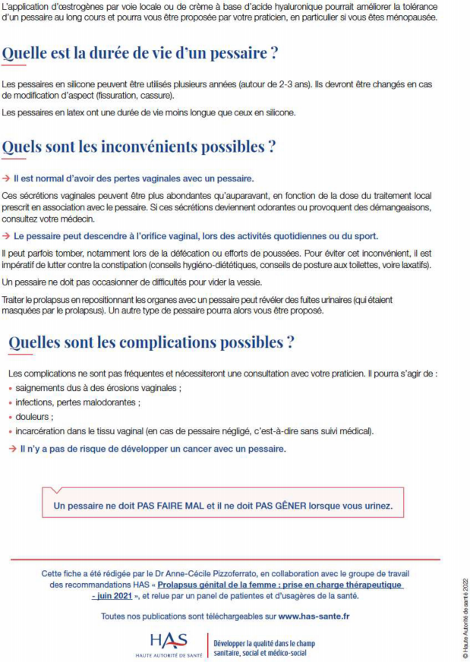

A.-C. Pizzoferrato, C. Thuillier, A. Venara et al. Journal of Gynecology Obstetrics and Human Reproduction 52 (2023) 102535

References
[1] Barber MD, Maher C. Epidemiology and outcome assessment of pelvic organ pro- lapse. Int Urogynecol J 2013;24(11):1783–90.
[2] Lowenstein L, Gamble T, Sanses TVD, van Raalte H, Carberry C, Jakus S, et al. Sex- ual function is related to body image perception in women with pelvic organ pro- lapse. J Sex Med 2009;6(8):2286-91.
[3] Jelovsek JE, Barber MD. Women seeking treatment for advanced pelvic organ pro- lapse have decreased body image and quality of life. Am J Obstet Gynecol 2006;194(5):1455-61.
[4] Ellerkmann RM, Cundiff GW, Melick CF, Nihira MA, Lefﬂer K, Bent AE. Correlation of symptoms with location and severity of pelvic organ prolapse. Am J Obstet Gynecol 2001;185(6):1332–7 discussion 7-8.
[5] Swift SE, Tate SB, Nicholas J. Correlation of symptoms with degree of pelvic organ support in a general population of women: what is pelvic organ prolapse? Am J Obstet Gynecol 2003;189(2):372–7 discussion 7-9.
[6] Ai F, Deng M, Mao M, Xu T, Zhu L. Depressive symptoms screening in postmeno- pausal women with symptomatic pelvic organ prolapse. Menopause 2018;25 (3):314–9.
[7] de Tayrac R, Deval B, Fernandez H, Mare、s P. Validation linguistique en franc,ais des versions courtes des questionnaires de symptomes (PFDI-20) et de qualitede vie (PFIQ-7) chez les patientes presentant un trouble de la statique pelvienne. J Gyne- col Obstet Hum Reprod 2007;36(8):738–48.
[8] Deparis J, Bonniaud V, Desseauve D, Guilhot J, Masanovic M, de Tayrac R, et al. Cultural adaptation of the female pelvic ﬂoor questionnaire (FPFQ) into French. Neurourol Urodyn 2017;36(2):253–8.
[9] Donon L, Warembourg S, Lapray JF, Cortesse A, Hermieu JF, Fatton B, et al. Bilan avant le traitement chirurgical d’un prolapsus genital : recommandations pour la pratique clinique. Prog Urol 2016;26(Suppl 1):S8–S26.
[10] Bump RC, Mattiasson A, Bø K, Brubaker LP, DeLancey JO, Klarskov P, Shull BL, Smith AR. The standardization of terminology of female pelvic organ prolapse and pelvic ﬂoor dysfunction. Am J Obstet Gynecol 1996 Jul;175(1):10–7.
[11] Baden WF, Walker TA. Genesis of the vaginal proﬁle : a correlated classiﬁcation of vaginal relaxation. Clin Obstet Gynecol 1972;15(4):1048–54.
[12] Vergeldt TF, Weemhoff M, IntHout J, Kluivers KB. Risk factors for pelvic organ pro- lapse and its recurrence: a systematic review. Int Urogynecol J 2015;26 (11):1559–73.
[13] Kudish BI, Iglesia CB, Sokol RJ, Cochrane B, Richter HE, Larson J, et al. Effect of weight change on natural history of pelvic organ prolapse. Obstet Gynecol 2009;113(1):81–8.
[14] Pizzoferrato AC, Fritel X. Preoperative functional explorations of genital prolapse (urodynamics, dynamic MRI). Gynecol Obstet Fertil Senol 2018;46(7-8):593–7.
[15] El Sayed RF, Alt CD, Maccioni F, Meissnitzer M, Masselli G, Manganaro L, et al. Magnetic resonance imaging of pelvic ﬂoor dysfunction - joint recommendations of the ESUR and ESGAR Pelvic Floor Working Group. Eur Radiol 2017;27 (5):2067–85.
[16] Basu M, Duckett JR. Barriers to seeking treatment for women with persistent or recurrent symptoms in urogynaecology. BJOG 2009;116(5):726–30.
[17] Chen CCG, Cox JT, Yuan C, Thomaier L, Dutta S. Knowledge of pelvic ﬂoor disor- ders in women seeking primary care: a cross-sectional study. BMC Fam Pract 2019;20(1):70.
[18] Mandimika CL, Murk W, Muhlhauser McPencow A, Lake A, Wedderburn T, Collier CH, et al. Knowledge of pelvic ﬂoor disorders in a population of community- dwelling women. Am J Obstet Gynecol 2014;210(2) 165 e1-9.
[19] Due U, Brostrøm S, Lose G. Lifestyle advice with or without pelvic ﬂoor muscle training for pelvic organ prolapse: a randomized controlled trial. Int Urogynecol J 2016;27(4):555–63.
[20] Blanchard V, Nyangoh-Timoh K, Fritel X, Fauconnier A, Pizzoferrato AC. Impor- tance of a pelvic ﬂoor lifestyle program in women with pelvic ﬂoor dysfunctions: a pilot study. J Gynecol Obstet Hum Reprod 2021;50(4):102032.
[21] Hagen S, Stark D, Glazener C, Dickson S, Barry S, Elders A, et al. Individualised pel- ﬂoor muscle training in women with pelvic organ prolapse (POPPY): a multi-vic centre randomised controlled trial. The Lancet 2014;383(9919):796–806.
[22] Braekken IH, Majida M, Engh ME, Bo K. Can pelvic ﬂoor muscle training reverse pelvic organ prolapse and reduce prolapse symptoms? An assessor-blinded, ran- domized, controlled trial. Am J Obstet Gynecol 2010;203(2) 170 e1-7.
[23] Wiegersma M, Panman CM, Kollen BJ, Berger MY, Lisman-Van Leeuwen Y, Dekker JH. Effect of pelvic ﬂoor muscle training compared with watchful waiting in older women with symptomatic mild pelvic organ prolapse: randomised controlled trial in primary care. BMJ 2014;349:g7378.
[24] Resende APM, Bernardes BT, Stu“pp L, Oliveira E, Castro RA, Girao MJBC, et al. -Pel vic ﬂoor muscle training is better than hypopressive exercises in pelvic organ pro- lapse treatment: an assessor-blinded randomized controlled trial. Neurourol Urodyn 2019;38(1):171–9.
[25] Gorji Z, Pourmomeny AA, Hajhashemy M. Evaluation of the effect of a new method on the pelvic organ prolapse symptoms. Low Urin Tract Symptoms 2020;12(1):20–4.
[26] Brown LK, Fenner DE, DeLancey JOL, Schimpf MO. Deﬁning patient knowledge and perceptions of vaginal pessaries for prolapse and incontinence. Female Pelvic Med Reconstr Surg 2016;22(2):93–7.
[27] Kapoor DS, Thakar R, Sultan AH, Oliver R. Conservative versus surgical manage- ment of prolapse: what dictates patient choice? Int Urogynecol J Pelvic Floor Dys- funct 2009;20(10):1157–61.
[28] Clemons JL, Aguilar VC, Tillinghast TA, Jackson ND, Myers DL. Patient satisfaction and changes in prolapse and urinary symptoms in women who were ﬁtted

successfully with a pessary for pelvic organ prolapse. Am J Obstet Gynecol 2004;190(4):1025–9.
[29] Fernando RJ, Thakar R, Sultan AH, Shah SM, Jones PW. Effect of vaginal pessaries on symptoms associated with pelvic organ prolapse. Obstet Gynecol 2006;108 (1):93–9.
[30] Mao M, Ai F, Kang J, Zhang Y, Liang S, Zhou Y, et al. Successful long-term use of Gellhorn pessary and the effect on symptoms and quality of life in women with symptomatic pelvic organ prolapse. Menopause 2019;26(2):145–51.
[31] Markle D, Skoczylas L, Goldsmith C, Noblett K. Patient characteristics associated with a successful pessary ﬁtting. Female Pelvic Med Reconstr Surg 2011 Sep;17 (5):249–52.
[32] Deng M, Ding J, Ai F, Zhu L. Successful use of the Gellhorn pessary as a second-line pessary in women with advanced pelvic organ prolapse. Menopause 2017;24 (11):1277–81.
[33] Panman CM, Wiegersma M, Kollen BJ, Burger H, Berger MY, Dekker JH. Predictors of unsuccessful pessary ﬁtting in women with prolapse: a cross-sectional study in general practice. Int Urogynecol J 2017 Feb;28(2):307–13.
[34] Hanson L-AM, Schulz JA, Flood CG, Cooley B, Tam F. Vaginal pessaries in managing women with pelvic organ prolapse and urinary incontinence: patient characteris- tics and factors contributing to success. Int Urogynecol J Pelvic Floor Dysfunct 2006;17(2):155–9.
[35] HockeC, Diaz M, Bernard V, Frantz S, Lambert M, Mathieu C, Grellety-Cherbero M. Syndrome genito-urinaire de la menopause (SGUM). RPC les femmes
menopausees du CNGOF et du GEMVi. Gynecol Obstet Fertil Senol 2021;49
(5):394–413.
[36] Broekhuis SR, Futterer JJ, Hendriks JC, Barentsz JO, Vierhout ME, Kluivers KB. Symptoms of pelvic ﬂoor dysfunction are poorly correlated with ﬁndings on clini- cal examination and dynamic MR imaging of the pelvic ﬂoor. Int Urogynecol J Pel- vic Floor Dysfunct 2009;20(10):1169–74.
[37] Ramage L, Simillis C, Yen C, Lutterodt C, Qiu S, Tan E, et al. Magnetic resonance defecography versus clinical examination and ﬂuoroscopy: a systematic review and meta-analysis. Tech Coloproctol 2017;21(12):915–27.
[38] Visco AG, Brubaker L, Nygaard I, Richter HE, Cundiff G, Fine P, et al. The role of preoperative urodynamic testing in stress-continent women undergoing sacro- colpopexy: the Colpopexy and Urinary Reduction Efforts (CARE) randomized sur- gical trial. Int Urogynecol J Pelvic Floor Dysfunct 2008;19(5):607–14.
[39] National Institute for Health and Care Excellence. Urinary incontinence and pelvic organ prolapse in women: management. London: NICE; 2019. Guideline https:// www.nice.org.uk/guidance/ng123/resources/urinary-incontinence-and-pelvic-
organ-prolapse-in-women-management-pdf-66141657205189.
[40] Ridgeway BM, Weinstein MM, Tunitsky-Bitton E. American Urogynecologic Soci- ety best-practice statement on evaluation of obstructed defecation. Female Pelvic Med Reconstr Surg 2018;24(6):383–91.
[41] Le Normand L, Cosson M, Cour F, Defﬁeux X, Donon L, Ferry P, Fatton B, Hermieu JF, Marret H, Meurette G, Cortesse A, Wagner L, Fritel X. [Clinical practice guide- lines: synthesis of the guidelines for the surgical treatment of primary pelvic organ prolapse in women by the AFU, CNGOF, SIFUD-PP, SNFCP, and SCGP]. J Gynecol Obstet Biol Reprod 2016 Dec;45(10):1606–13.
[42] Young SB, Daman JJ, Bony LG. Vaginal paravaginal repair: one-year outcomes. Am J Obstet Gynecol. dec 2001;185(6):1360-6. discussion 1366-1367.
[43] Cam C, Karateke A, Asoglu MR, Selcuk S, Namazov A, Aran T, et al. Possible cause of failure after McCall culdoplasty. Arch Gynecol Obstet. avr 2011;283(4):791-4.
[44] Halpern-Elenskaia K, Umek W, Bodner-Adler B, Hanzal E. Anterior colporrhaphy: a standard operation? Systematic review of the technical aspects of a common procedure in randomized controlled trials. Int Urogynecol J. 2018;29(6):781-8.
[45] Siddiqui NY, Grimes CL, Casiano ER, Abed HT, Jeppson PC, Olivera CK, et al. Mesh sacrocolpopexy compared with native tissue vaginal repair: a systematic review and meta-analysis. Obstet Gynecol 2015;125(1):44–55.
[46] Maher C, Feiner B, Baessler K, Christmann-Schmid C, Haya N, Brown J. Surgery for women with anterior compartment prolapse. Cochrane Database Syst Rev 2016 (Issue 11):CD004014.
[47] Nair R, Nikolopoulos KI, Claydon LS. Clinical outcomes in women undergoing lap- aroscopic hysteropexy: a systematic review. Eur J Obstet Gynecol Reprod Biol 2017;208:71–80.
[48] Ganatra AM, Rozet F, Sanchez-Salas R, Barret E, Galiano M, Cathelineau X, et al. The current status of laparoscopic sacrocolpopexy: a review. Eur Urol 2009;55 (5):1089–103.
[49] Campbell P, Cloney L, Jha S. Abdominal versus laparoscopic sacrocolpopexy: a sys- tematic review and meta-analysis. Obstet Gynecol Surv 2016;71(7):435–42.
[50] FitzGerald MP, Richter HE, Siddique S, Thompson P, Zyczynski H. Ann weber for the pelvic ﬂoor disorders network. Colpocleisis: a review. Int Urogynecol J Pelvic Floor Dysfunct. mai 2006;17(3):261-71.
[51] Defﬁeux X, Thubert T, Donon L, Hermieu J-F, Le Normand L, Trichot C. [Colpoclei- sis: guidelines for clinical practice]. Prog Urol. juill 2016;26(Suppl 1):S61–72.
[52] Nygaard IE, McCreery R, Brubaker L, Connolly A, Cundiff G, Weber AM, et al. Abdominal sacrocolpopexy: a comprehensive review. Obstet Gynecol 2004;104 (4):805–23.
[53] Grimes CL, Schimpf MO, Wieslander CK, Sleemi A, Doyle P, Wu YM, et al. Surgical interventions for posterior compartment prolapse and obstructed defecation symptoms: a systematic review with clinical practice recommendations. Int Uro- gynecol J 2019;30(9):1433–54.
[54] Mowat A, Maher D, Baessler K, Christmann-Schmid C, Haya N, Maher C. Surgery for women with posterior compartment prolapse. Cochrane Database Syst Rev 2018(Issue 3):CD012975.
[55] Meriwether KV, Antosh DD, Olivera CK, Kim-Fine S, Balk EM, Murphy M, et al. Uterine preservation vs hysterectomy in pelvic organ prolapse surgery: a

A.-C. Pizzoferrato, C. Thuillier, A. Venara et al. Journal of Gynecology Obstetrics and Human Reproduction 52 (2023) 102535

systematic review with meta-analysis and clinical practice guidelines. Am J Obstet Gynecol 2018;219(2):129-46 e2.
[56] Hoke TP, Tan-Kim J, Richter HE. Evidence-based review of vaginal native tis- sue hysteropexy for uterovaginal prolapse. Obstet Gynecol Surv 2019;74 (7):429-35.
[57] Cortesse A, Cardot V, Basset V, Le Normand L, Donon L. [Treatment of Urinary incontinence associated with genital prolapse: clinical practice guidelines]. Prog Urol 2016;26(Suppl 1):S89-97 Jul.
[58] van der Ploeg JM, van der Steen A, Zwolsman S, van der Vaart CH, Roovers J. Pro- lapse surgery with or without incontinence procedure: a systematic review and meta-analysis. BJOG 2018;125(3):289-97.
[59] Diwadkar GB, Barber MD, Feiner B, Maher C, Jelovsek JE. Complication and reop- eration rates after apical vaginal prolapse surgical repair: a systematic review. Obstet Gynecol 2009;113(2 Pt 1):367-73.

[60] Abed H, Rahn DD, Lowenstein L, Balk EM, Clemons JL, Rogers RG. Incidence and management of graft erosion, wound granulation, and dyspareunia following vaginal prolapse repair with graft materials: a systematic review. Int Urogynecol J 2011;22(7):789-98.
[61] Jia X, Glazener C, Mowatt G, Jenkinson D, Fraser C, Bain C, et al. Systematic review of the efﬁcacy and safety of using mesh in surgery for uterine or vaginal vault pro- lapse. Int Urogynecol J 2010;21(11):1413-31.
[62] Zhang FW, Wei F, Wang HL, Pan YQ, Zhen JY, Zhang JX, et al. Does pelvic ﬂoor muscle training augment the effect of surgery in women with pelvic organ pro- lapse? A systematic review of randomized controlled trials. Neurourol Urodyn 2016;35(6):666-74.
[63] Haya N, Feiner B, Baessler K, Christmann-Schmid C, Maher C. Perioperative inter- ventions in pelvic organ prolapse surgery. Cochrane Database Syst Rev 2018(Issue 8):CD013105.

